

**NATIONAL UNIVERSITY OF SCIENCES & TECHNOLOGY**

**Linear Control Systems (EE-371)**

**Assignment # 3**

(CLO-2)

**Submission Details**

|  |  |
| --- | --- |
| Submitted to: | Ms. Neelma Naz |
| Submitted by: | Muhammad Umer |
| Class: | BEE-12C |
| Semester: | 6th |
| Dated: | 16/3/2023 |
| CMS ID: | 345834 |

**In this case study, we investigate the time response of the vehicle dynamics that relate the pitch angle output to the elevator deflection input.**

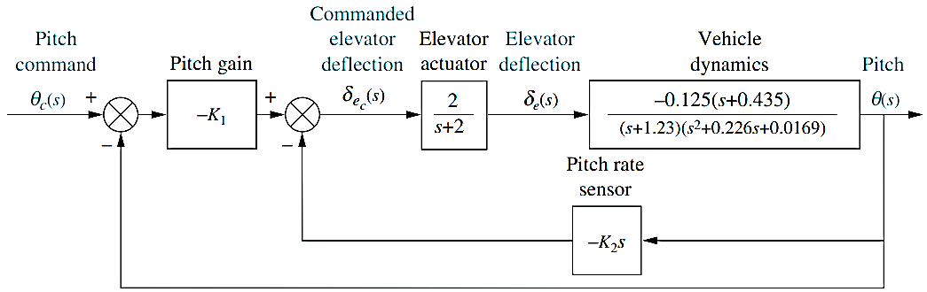

Figure 1: Pitch control loop for the UFSS vehicle

**Requirements:**

1. Using the knowledge of subsystem reduction, reduce the above block diagram to a single transfer function, and compare the response of both the reduced and the original system.

**Common Shifts in Block Diagram Reduction:**

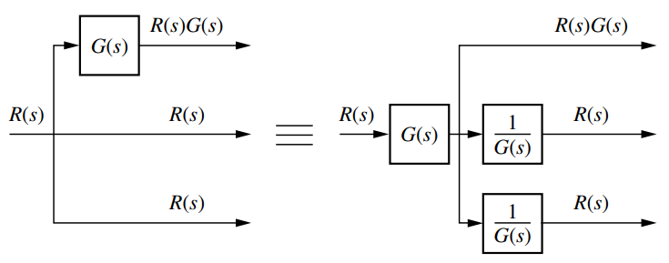 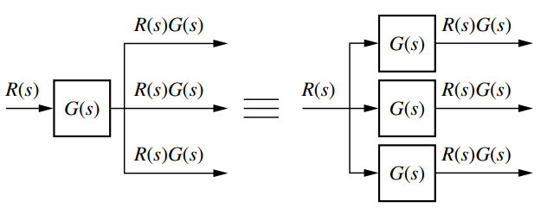

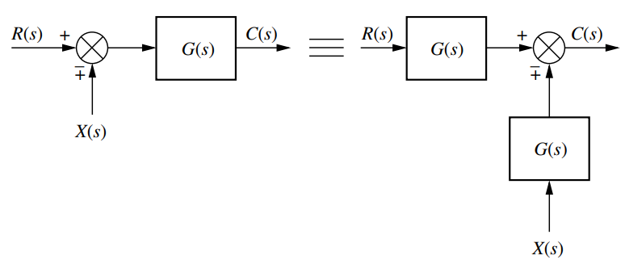

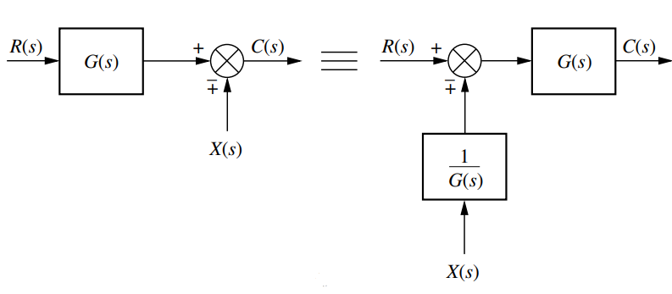

# Full System Model

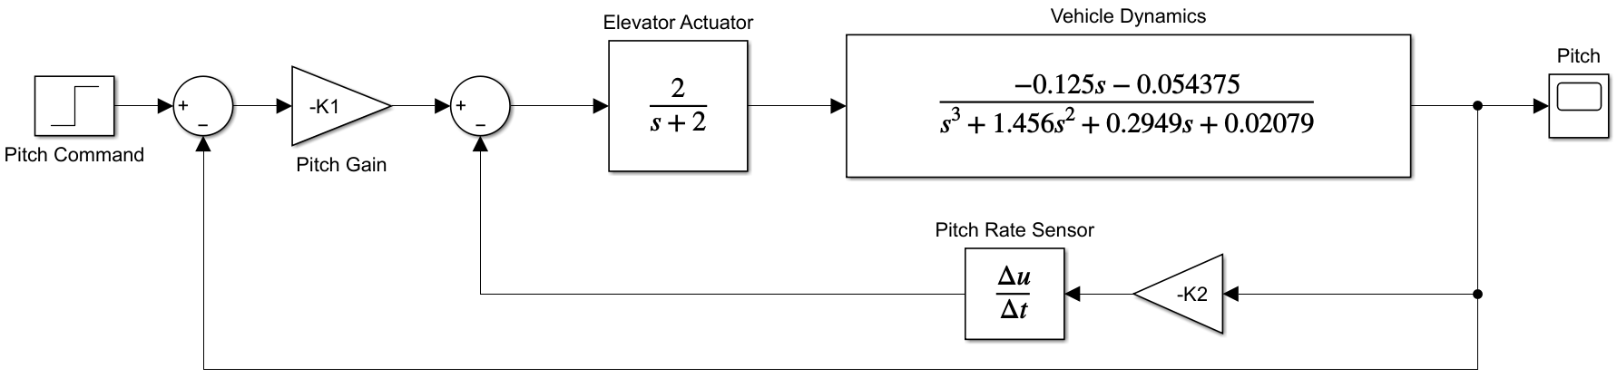

The transfer function in [num, den] form for vehicle dynamics was found through the following code:

%% Pitch response to elevator deflection

display(roots([1, 0.226, 0.0169]))

v_dyn = zpk(-0.435, [-1.23, -0.1130+0.0643i, -0.1130-0.0643i], -0.125);

% Coeffs for tf block in Simulink

display(tf(v_dyn))

The unit step response of the above Simulink model is as follows:

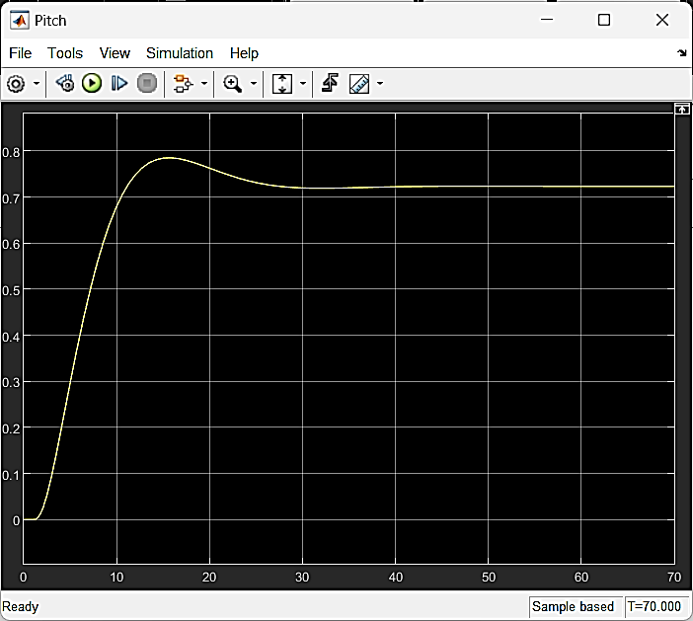

Figure 2: Unit step response of complete system model

# Reduced System Simplification

Complete calculations done by hand have been appended to this printout, however, the symbolic toolbox of MATLAB was utilized to verify the reduction results.

%% Simplification

syms s;

syms s K1 K2;

G1 = -K1;

G2 = 2/(s+2);

G3 = (-0.125)*(s+0.435)/((s+1.23)*(s^2+0.226*s+0.0169));

H = -K2*s;

reduced_sys = (G1*G2*G3)/(1+(G1*G2*G3)+(G2*G3*H));

reduced_sys =

(2*K1*(s/8 + 87/1600))/((s + 2)*(s + 123/100)*(s^2 + (113*s)/500 + 169/10000)*((2*K1*(s/8 + 87/1600))/((s + 2)*(s + 123/100)*(s^2 + (113*s)/500 + 169/10000)) + (2*K2*s*(s/8 + 87/1600))/((s + 2)*(s + 123/100)*(s^2 + (113*s)/500 + 169/10000)) + 1))

# Reduced System Model

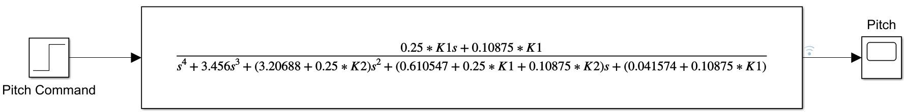

The unit step response of the above Simulink model is as follows:



Figure 3: Unit step response of reduced system model

# Response Comparison

Knowing that the reduction of subsystems is not an approximation of the system, but rather a different way of expressing the system, we expect the response of either system to any input to be the same. Utilizing “hold on” command of MATLAB, we can compare the resultant response plots:

%% Comparison

figure

hold on

plot(reduced, 'LineWidth', 1.15)

plot(original, '--', 'LineWidth', 1)

xlabel('Time (s)')

ylabel('Magnitude')

title('Comparison of Step Response')

legend('Reduced', 'Original')

grid

